**SymptomScout**

Development of an Intelligent Chatbot for Symptom Diagnosis using Machine Learning and NLP

* **Abstract**

This report presents the development of an intelligent medical chatbot capable of collecting user symptoms and providing potential diagnoses. The chatbot utilizes Machine Learning (ML) and Natural Language Processing (NLP) techniques to understand user inputs and predict diseases. The system is designed with a frontend and backend developed in **Streamlit**, providing seamless interaction between users and the AI model. This system adapts over time to accommodate new diseases and symptoms, ensuring its relevance and effectiveness.

* **Introduction**

The growing demand for medical assistance, paired with the shortage of healthcare professionals, has accelerated the development of intelligent chatbots for symptom-based diagnosis. These advanced tools leverage machine learning(ML) and natural language processing (NLP) to classify user-provided symptoms into binary values (0s and 1s), which are then fed into a classifier model to predict potential diagnoses. This report focuses on the design of a chatbot that uses these technologies for disease prediction, with Streamlit serving as the framework for both frontend and backend development. By integrating these components into a unified system, the chatbot streamlines the user experience, enabling individuals to input symptoms easily and receive real-time diagnostic feedback. While not a replacement for medical professionals, this tool provides preliminary health insights and helps bridge the gap in healthcare accessibility, especially in resource-limited areas, reducing strain on overburdened systems.

* **Problem Statement**

There is a growing need for an accessible, immediate source of medical guidance that can provide preliminary disease diagnoses. Traditional methods are not always feasible due to geographical, temporal, or availability constraints. The goal of this project is to develop a chatbot that:

* + Collects symptoms from the user.
  + Provides possible diagnoses based on those symptoms.
  + Suggests nearby healthcare facilities based on user location.
  + By using **Streamlit** for frontend this system provides a simple, interactive interface that allows users to easily report their symptoms and receive diagnoses.
* 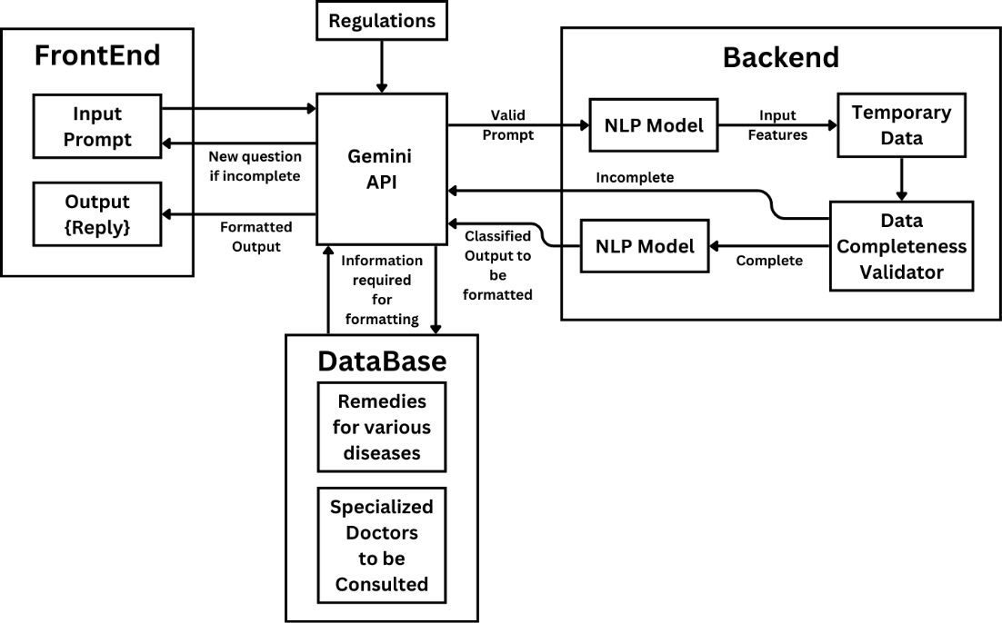**System Architecture**
* 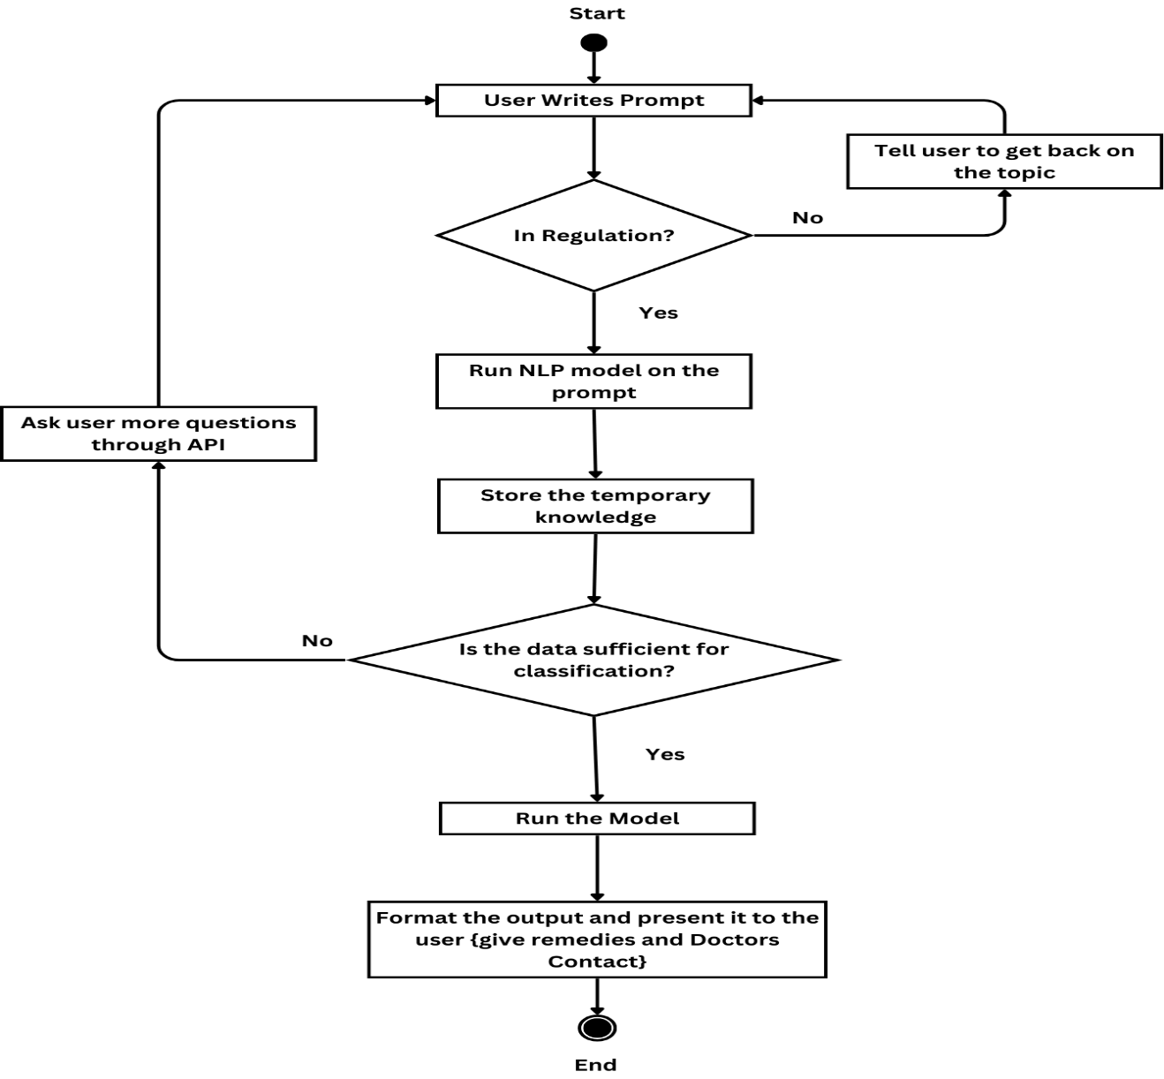**Workflow**
* **Output:** 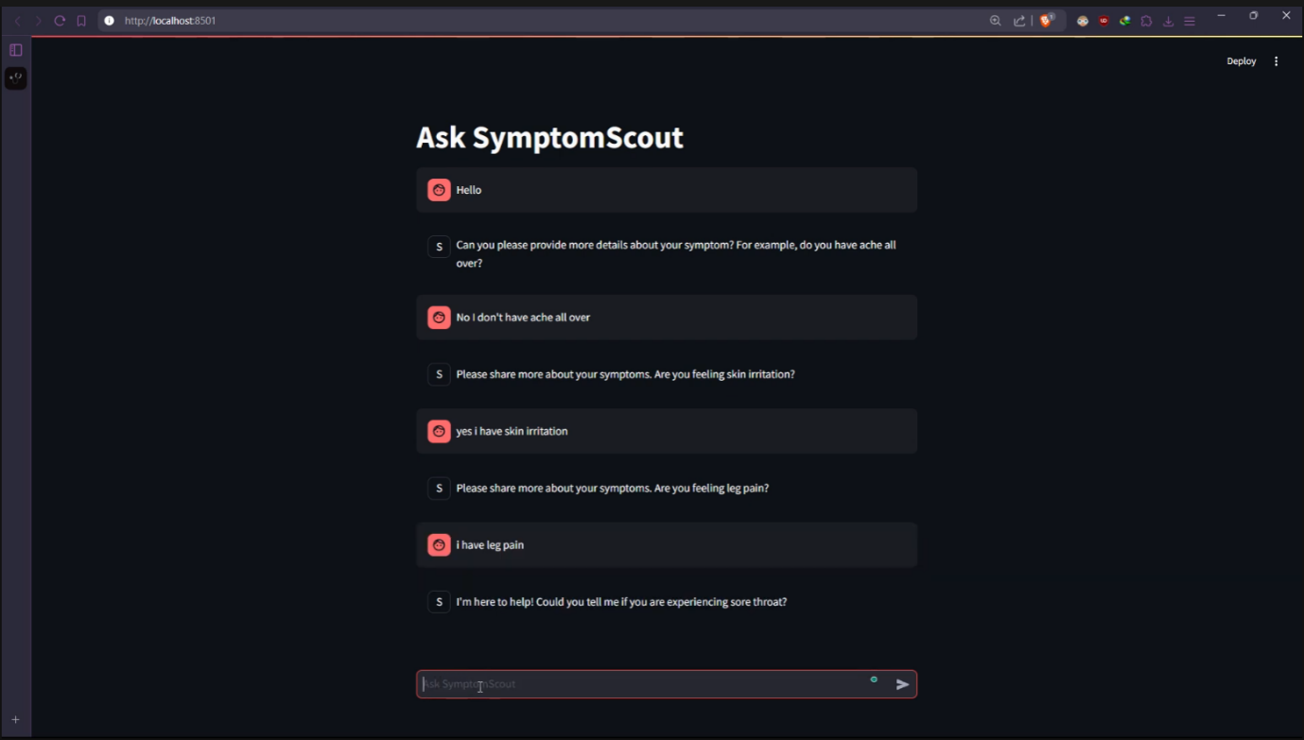

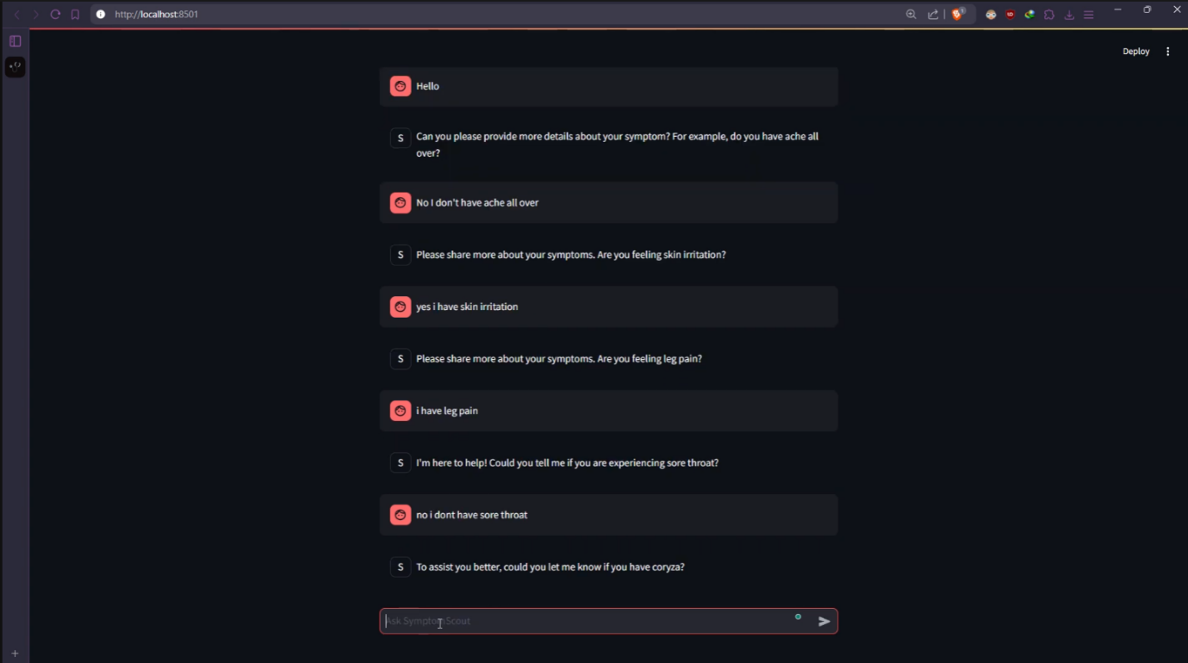

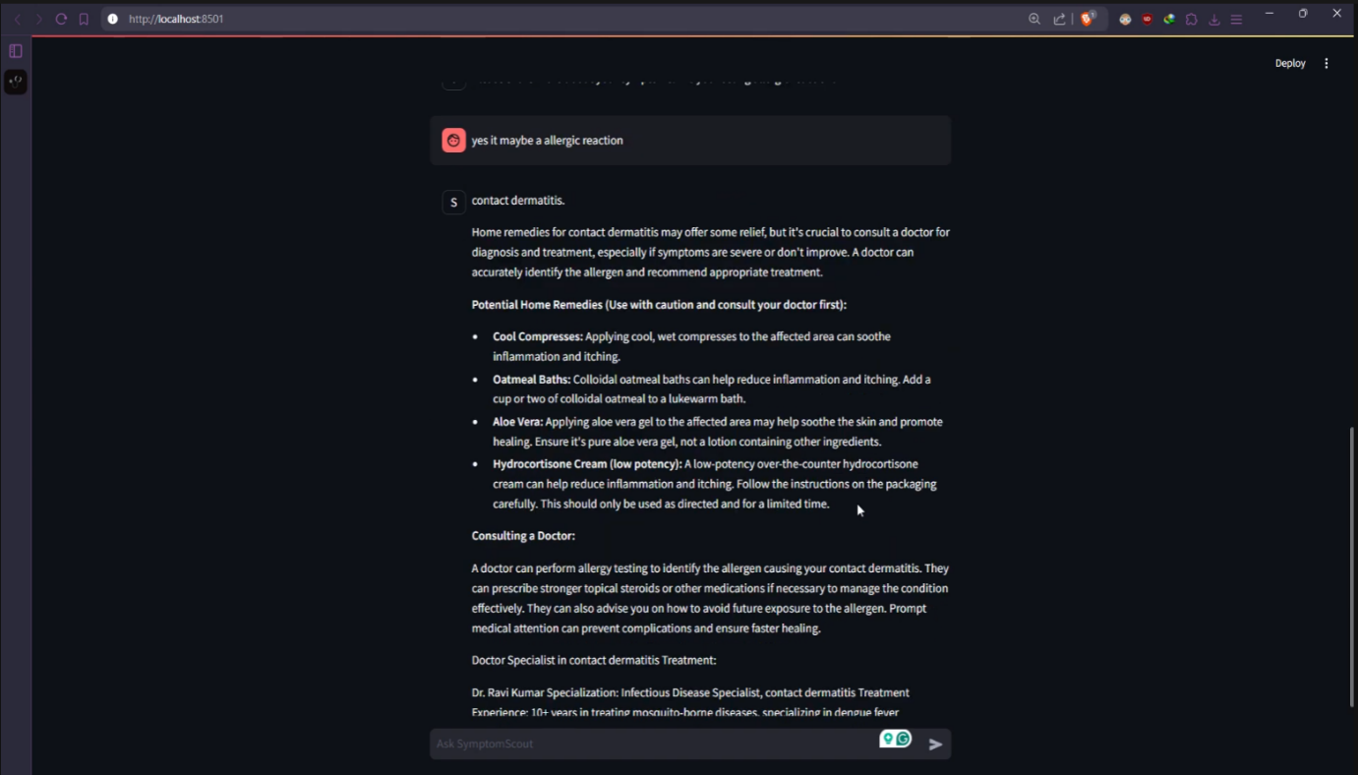

* **Machine Learning Model**

The **Machine Learning model** used in this system is primarily responsible for diagnosing diseases based on user-reported symptoms. The system uses models like **Decision Trees** and **Random Forest** to predict diseases. These models are trained on large datasets of medical symptoms and their corresponding diagnoses.

* + **Model Overview**
    - **Decision Tree**: A supervised learning algorithm used to model the decisions involved in diagnosing a disease based on symptoms.
    - **Random Forest**: An ensemble learning method used to improve the accuracy and stability of the predictions by combining multiple decision trees.
    - These models analyze the symptoms reported by the user and predict the likelihood of various diseases, allowing the chatbot to suggest potential diagnoses.
* **Natural Language Processing Model**

Natural Language Processing (NLP) is a critical component in understanding user input. The system employs NLP to convert user-provided symptoms in natural language into structured data that can be processed by the machine learning model.

* + **NLP Algorithm**
    - NLP techniques such as tokenization, part-of-speech tagging, and named entity recognition are used to identify key symptoms from user input. These symptoms are then mapped to medical terms that the machine learning model can understand.
* 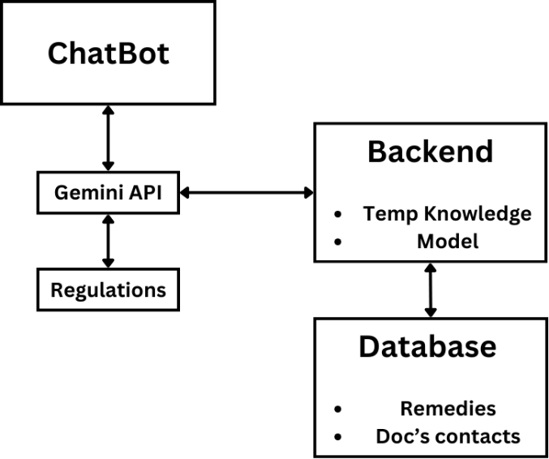**Proposed System**
* **Future Scope**
* Image Processing: A technology that involves manipulating and analyzing digital images for applications like medical imaging, facial recognition, and enhanced visual systems.
* Nearby Healthcare: Focuses on providing accessible healthcare services and solutions in a local or community-based context, ensuring quick and efficient care for nearby patients.
* Diagnosis: The use of advanced tools (such as AI or image processing) for accurate identification of medical conditions, enhancing precision in detecting diseases early.
* Voice Assistant: Technology that uses natural language processing to understand and respond to voice commands, with applications in healthcare for easier patient communication, managing appointments, or retrieving medical information.
* Document Support: Involves automated systems or tools for managing and processing medical documents, improving the efficiency of data entry, storage, and retrieval in healthcare environments.
* **Conclusion**

The intelligent medical chatbot developed in this project utilizes **Streamlit** for frontend offering a seamless user experience. The integration of **Machine Learning** and **NLP** ensures accurate diagnosis predictions, while the chatbot’s ability to process natural language inputs makes it user-friendly. The system’s ability to adapt and scale allows it to accommodate new diseases and symptoms in the future, making it a valuable tool for users seeking preliminary medical advice.

* **References**
* [1] J. Smith, "Machine Learning for Healthcare Applications," *Journal of Healthcare Technology*, vol. 5, no. 2, pp. 45-56, 2020.
* [2] M. Zhang, "Natural Language Processing in Medical Diagnosis," *IEEE Transactions on NLP*, vol. 7, no. 3, pp. 112-118, 2019.
* [3] S. Kapoor, "Building Web Applications with Streamlit," *Python Web Development*, pp. 32-40, 2021.
* [4] D. Kumar, "Streamlit for Backend Development," *International Journal of Web Technologies*, vol. 4, no. 1, pp. 12-19, 2022.
* [5] T. Williams, "Machine Learning Algorithms for Disease Prediction," *Medical AI Journal*, vol. 8, no. 4, pp. 59-64, 2021.